Past Chair

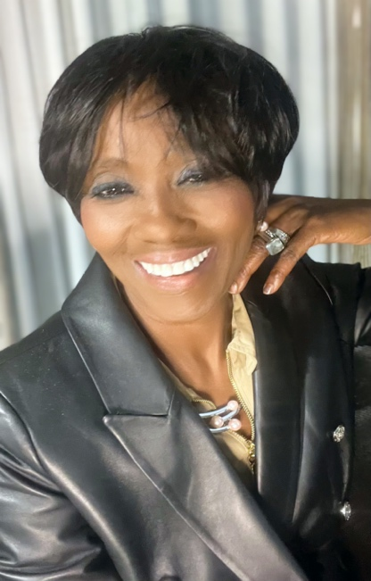
Rev. Inetta Reddell, MA-Bioethics, MACS, MDIV, BCC
Staff Chaplain, Mission & Spiritual Care
Certified Educator Supervisor Fellow, Clinical Pastoral Education
Advocate Condell Medical Center

Rev. Inetta A. Reddell is a Clinical Pastoral Education Fellow, chaplain, and Certified Educator Candidate.

Rev. Reddell has over x number of years in chaplain ministry and began her healthcare chaplaincy at Advocate Lutheran General Hospital in 2008. Since then, Inetta has served as a chaplain in Texas where she was the first female and staff chaplain of color to serve at the University Medical Center in Lubbock Texas, in addition to her experience in trauma, prison, and a host of community ministry service.

Upon returning to Illinois in 2019, Inetta realized an opportunity to utilize her vast clinical experience and passion for education. She rejoined Advocate Aurora and has served at Advocate Condell Medical Center and Aurora Kenosha Medical Center.

Inetta serves on the Executive Board of Directors of the Association of Professional Chaplains and as an Out-of-District Pastor for the United Methodist Church. She lives in McHenry, IL with her husband and two dogs Samson and Taylor. She spends time with her mother, grandchildren, and extended family when she is not working.

